**PRACTICE PROBLEMS (Chap 1, Chap2)**

**Problem: Two tollbooths are located 60 km apart on a highway. Cars travel between these tollbooths at a speed of 80 km/hr. Each tollbooth services a car at a rate of one car every 15 seconds. Calculate the total delay experienced by a car traveling between the two tollbooths.**

Solution:

Service Time= 15 seconds each car (at each tool)

1. **Propagation Delay:**
   * The distance between tollbooths is 60 km.
   * Time = Distance / Speed = 60 km / 80 km/hr = 0.75 hours = 45 minutes. (Propagation Delay)
2. **Delay Between Tollbooths:**
   * The delay due to service time at each tollbooth is 15 seconds.
   * The delay due to propagation between tollbooths is 45 minutes.
   * So, the total delay between tollbooths is 45 minutes + 15 seconds = 45 minutes and 15 seconds.
3. **Total Delay:**
   * Since the delay occurs twice (once between each tollbooth), we multiply the delay between tollbooths by 2.
   * Total delay = 2 * (45 minutes and 15 seconds) = 90 minutes and 30 seconds.

Total delay experienced by a car traveling between the two tollbooths= 90 minutes and 30 seconds.

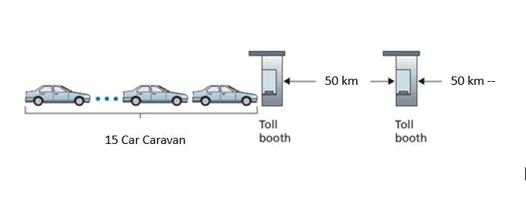

**Problem: Two tollbooths are located 50 km apart on a highway. Cars travel between these tollbooths at a speed of 120 km/hr. Each tollbooth services a car at a rate of one car every 16 seconds. Calculate the total delay experienced by a car traveling between the two tollbooths. Suppose there are 20 cars.**

Solution:

Delay for each car:

1. Service Time at Each Tollbooth:
   * Each tollbooth services a car every 16 seconds.
2. Propagation Delay:
   * The distance between tollbooths is 50 km.
   * At a speed of 120 km/hr, the time taken to travel between tollbooths is: Time = Distance / Speed = 50 km / 120 km/hr ≈ 0.4167 hours ≈ 25 minutes.
3. Delay for Each Car:
   * Each car experiences the propagation delay of 25 minutes.
   * Additionally, each car needs to wait for its turn to be serviced at the tollbooth, which adds a delay based on the service rate.
   * With 20 cars and a service rate of one car every 16 seconds, the delay for each car due to tollbooth service is: Delay per car = 20 cars * 16 seconds = 320 seconds = 5 minutes and 20 seconds.
4. Total Delay:
   * The total delay for each car is the sum of the propagation delay and the delay due to tollbooth service, which is 25 minutes + 5 minutes and 20 seconds = 30 minutes and 20 seconds.

**Now, to find the total delay experienced by all 20 cars collectively, we multiply the delay per car by the number of cars:**

Total delay = 20 cars * 30 minutes and 20 seconds.

**Let's calculate this:**

30 minutes * 20 cars = 600 minutes. 20 seconds * 20 cars = 400 seconds = 6 minutes and 40 seconds.

Total delay = 600 minutes + 6 minutes and 40 seconds.

So, the total delay experienced by all 20 cars collectively is 606 minutes and 40 seconds

**Problem: Combined Queueing and Transmission Delay A network link has a transmission rate of 1 Mbps. If the average queueing delay at the router connected to this link is 5 milliseconds and the packet size is 1000 bytes, calculate the combined queueing and transmission delay for a packet.**

Solution: Yet to be done!

**Problem:**

**Calculating End-to-End Delay with Processing, Queueing, and Propagation Delay**

**Consider a network path that consists of two routers connected by a transmission link. Each router has a processing delay of 5 milliseconds, and the transmission link has a bandwidth of 10 Mbps. The propagation delay along the link is 20 milliseconds. The average arrival rate of packets at each router is 200 packets per second, and the average service rate is 250 packets per second. Total packet size is 1000 bytes.**

**Calculate the end-to-end delay experienced by a packet traversing this network path, considering processing delay, queueing delay, and propagation delay.**

Solution:

Given:

* Processing delay at each router (Dproc) = 5 milliseconds
* Bandwidth of the transmission link (B) = 10 Mbps
* Propagation delay along the link (Dprop) = 20 milliseconds
* Packet Size = 1000 bytes
* Arrival rate at each router (λ) = 200 packets per second
* Service rate at each router (μ) = 250 packets per second
  1. Processing Delay: The processing delay at each router contributes to the end-to-end delay.

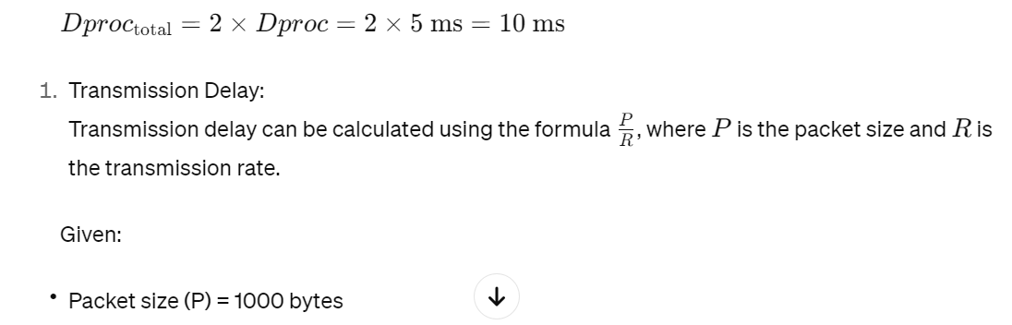

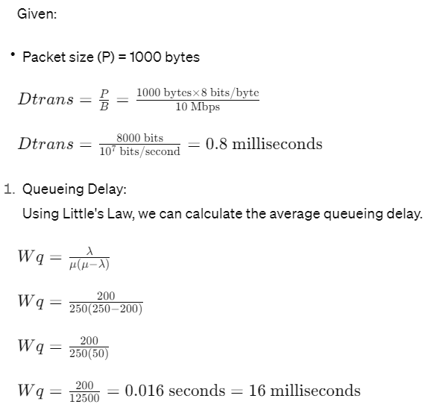

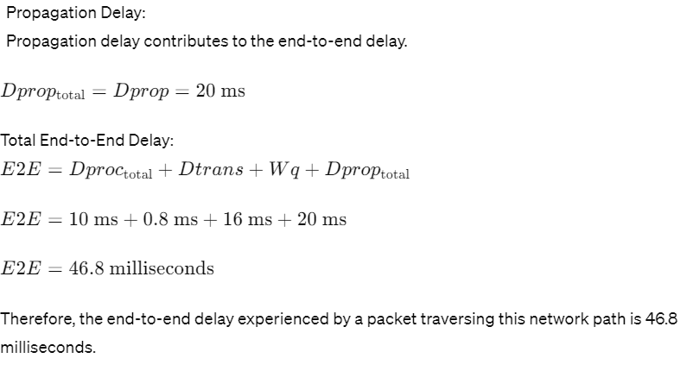

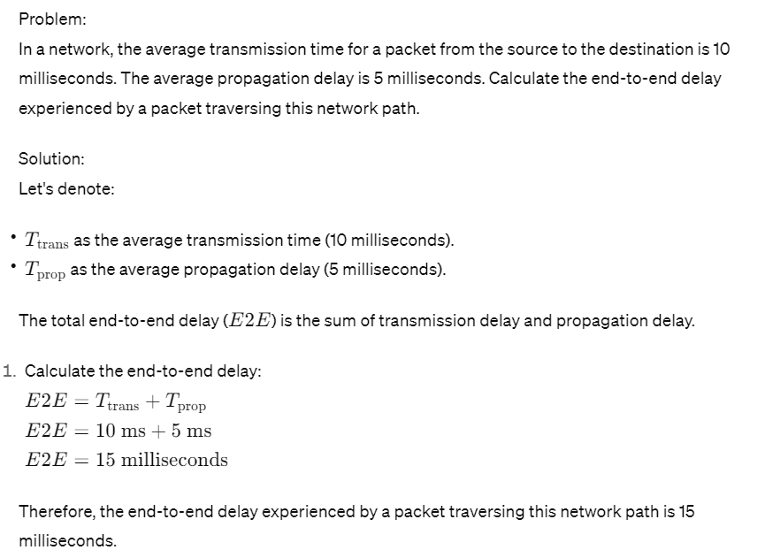

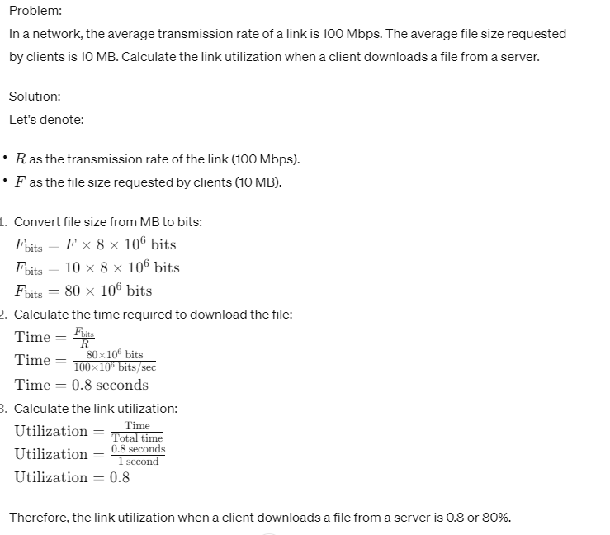

LAN delay=Queue size/Bandwidth

Problem: In this problem, we consider sending real-time voice from Host A to Host B over a packet-switched network (VoIP). Host A converts analog voice to a digital 64 kbps bit stream on the fly. Host A then groups the bits into 56-byte packets. There is one link between Hosts A and B; its transmission rate is 10 Mbps and its propagation delay is 10 msec. As soon as Host A gathers a packet, it sends it to Host B. As soon as Host B receives an entire packet, it converts the packet’s bits to an analog signal. How much time elapses from the time a bit is created (from the original analog signal at Host A) until the bit is decoded (as part of the analog signal at Host B)?

Solution:

To calculate the total time elapsed from the creation of a bit at Host A until it is decoded as part of the analog signal at Host B, we need to consider several components:

1. Transmission delay: The time it takes for a packet to be transmitted from Host A to Host B over the link.
2. Propagation delay: The time it takes for a signal to propagate from Host A to Host B.
3. Serialization delay: The time it takes to serialize the bits into a packet at Host A.
4. Deserialization delay: The time it takes to de-serialize the packet into bits at Host B.

Let's calculate each component:

1. Transmission delay: Given that the transmission rate is 10 Mbps and the packet size is 56 bytes, we can calculate the transmission delay using the formula:

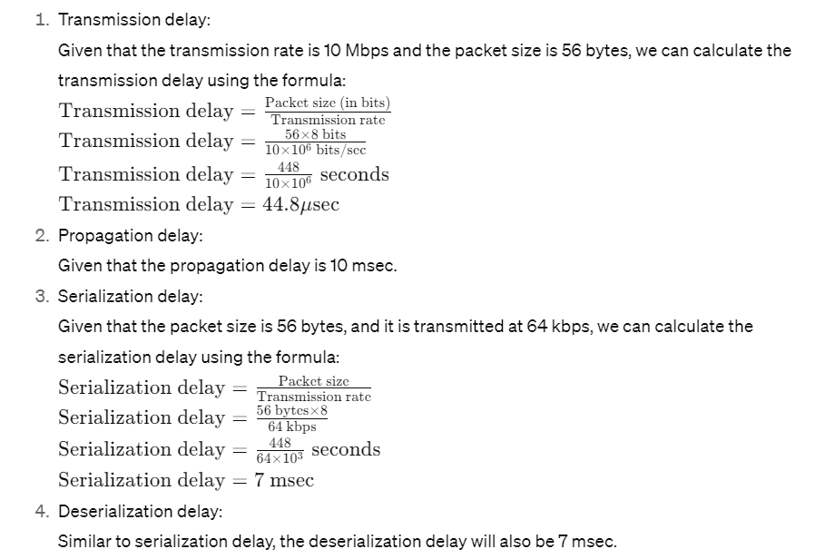

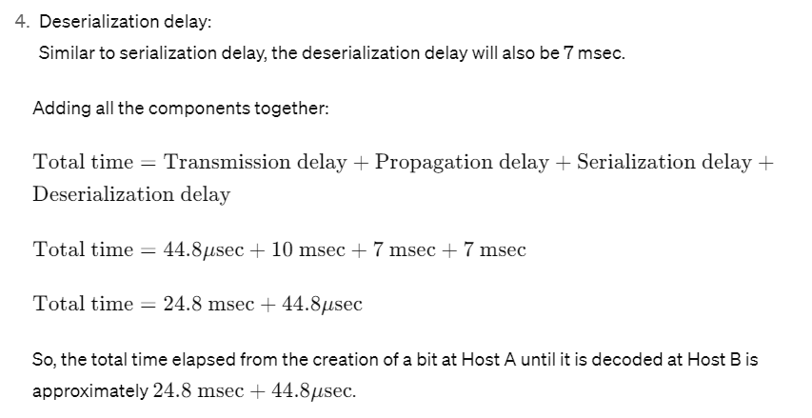

**Problem:**

Scenario:

access link rate: 154 Mbps

RTT from institutional router to server: 2 sec

web object size: 100K bits

average request rate from browsers to origin servers: 15/sec

avg data rate to browsers: 1.50 Mbps

1. **Transmission Time (Tt)**: This represents the time it takes to transmit the web object from the server to the institutional router.

Tt = Size of object / Access link rate

Tt = 100K bits / (154 Mbps)

Tt = (100,000 bits) / (154 * 10^6 bits/sec)

Tt ≈ 0.000649 seconds

1. **Propagation Time (Tp)**: This represents the round-trip time (RTT) from the institutional router to the server.

Tp = RTT / 2

Tp = 2 seconds / 2

Tp = 1 second

1. **Total Access Time (Ta)**: This is the sum of the transmission time and the propagation time.

Ta = Tt + Tp

Ta ≈ 0.000649 seconds + 1 second

Ta ≈ 1.000649 seconds

1. **Utilization**: Utilization represents the fraction of time the server is busy serving requests.

Utilization = (Data rate to browsers) / (Access link rate)

Utilization = 1.50 Mbps / 154 Mbps

Utilization ≈ 0.00974

Utilization ≈ 0.97%

1. **Average Delay (D)**: This represents the average time a request spends waiting in the queue.

D = 1 / (1 - Utilization)

D = 1 / (1 - 0.00974)

D ≈ 1.0099 seconds

Problem: access link rate: 1.54 Mbps

RTT from institutional router to server: 2 sec

web object size: 100K bits

average request rate from browsers to origin servers: 15/sec

avg data rate to browsers: 1.50 Mbps

Cache hit ratio: 0.4

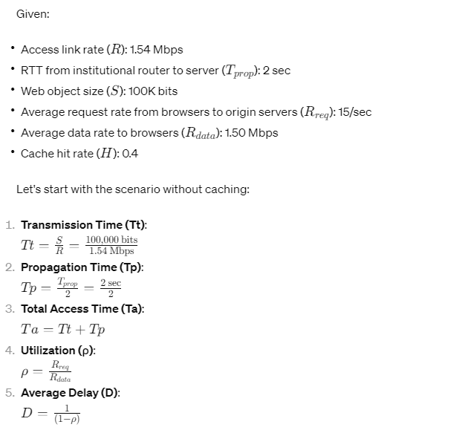

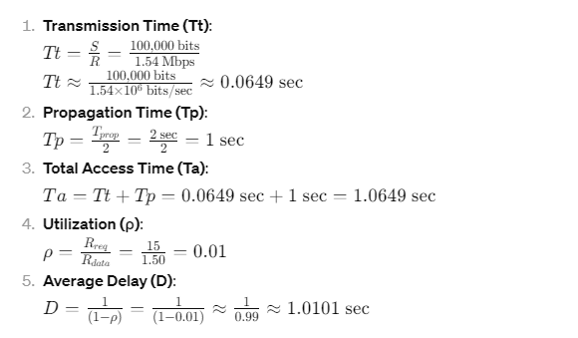

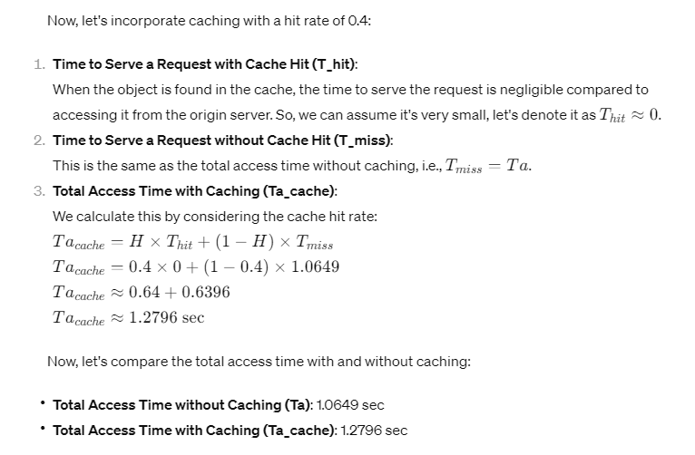

**Problem:**

**Consider the scenario shown below, with four different servers connected to four different clients over four three-hop paths. The four pairs share a common middle hop with a transmission capacity of R = 200 Mbps. The four links from the servers to the shared link have a transmission capacity of RS = 100 Mbps. Each of the four links from the shared middle link to a client has a transmission capacity of RC = 70 Mbps.**



**A) What is the maximum achievable end-end throughput (in Mbps) for each of four client-to-server pairs, assuming that the middle link is fairly shared?**

**Solution# R = 200Mbps/4 = 50Mbps. End to End Throughput = min {Rs, R, Rc} = {100Mbps, 50Mbps, 70Mbps} = End to End throughput = 50Mbps**

**B) Which link is the bottleneck link?**

**Solution# The middle link is bottleneck link**

**C) Assuming that the servers are sending at the maximum rate possible, what are the link utilizations for the server links (RS)?**

**Solution# Rs link Utilization = 50/100 = 0.5 or in % it is 50%**

**D) Assuming that the servers are sending at the maximum rate possible, what are the link utilizations for the client links (RC)?**

**Solution# Rc link utilization = 50/70 = 0.71 or in % it is 71%**

**E) Assuming that the servers are sending at the maximum rate possible, what is the link utilizations for the shared link (R)?**

**Solution# R link utilization = 50/50 = 1 or in % it is 100%**

**Problem:**

**Consider the figure below, with three links, each with the specified transmission rate and link length. Store & forward technique is used by switches.**



**Assume the length of a packet is 8000 bits. The speed of light propagation delay on each link is 3x10^8 m/sec.**

**A) What is total Transmission delay?**

**Solution# T1 + T2 + T3 = L/R1 + L/R2 + L/R3**

**Total transmission delay= (8000/1000x106) + (8000/10x106) + (8000/10x106)**

**Total Transmission delay = 1.608msec**

**B) What is total Propagation delay?**

**Solution# P1 + P2 + P3 = d1/s + d2/s + d3/s = (2x103/3x108) + (1000x103/3x108) + (1x103/3x108)**

**Total Propagation delay = 3.43msec**

**C) Calculate the total end to end delay?**

**Solution# Total end to end delay = Total transmission delay + total propagation delay**

**Total end to end delay = 1.608msec + 3.43msec = 5.038msec**

**D) What is end-end throughput & which link is bottleneck link?**

**Solution# Throughtput is 10Mbps & link 2 & 3 are bottleneck link**

**E) How many packets each link can send in a second?**

**Solution# R/L**

**Link 1 = 1000x106/8000 = 125000 packets in one sec**

**Link 2 & 3 = 10x106/8000 = 1250 Packets in one sec**